CS 255 System Design Document

Allan Torres
12/06/2025
CS-255-19206-M01

UML Diagrams

UML Use Case Diagram
Figure 1. Use Case Diagram
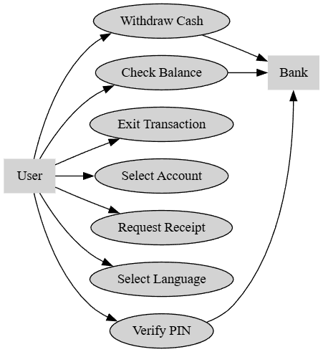

UML Activity Diagrams
Figure 2. Withdraw Cash Figure 3. Check Balance

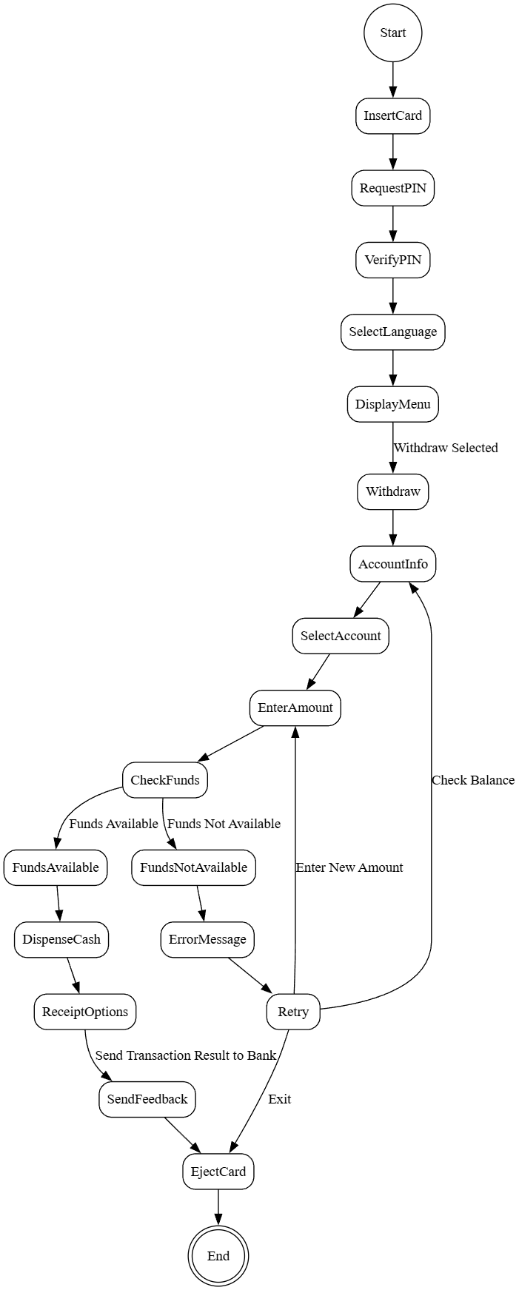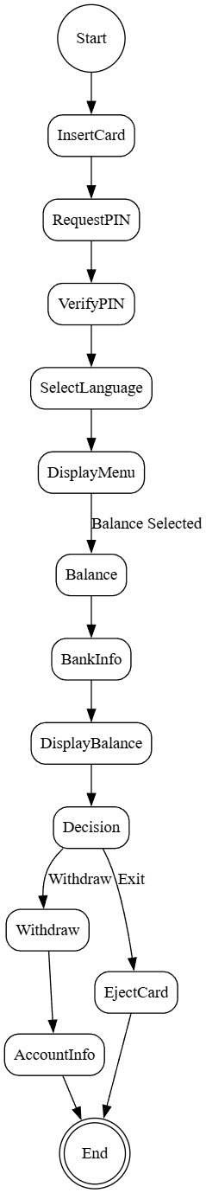

UML Sequence Diagram

Figure 4. Sequence Diagram: Withdraw Cash
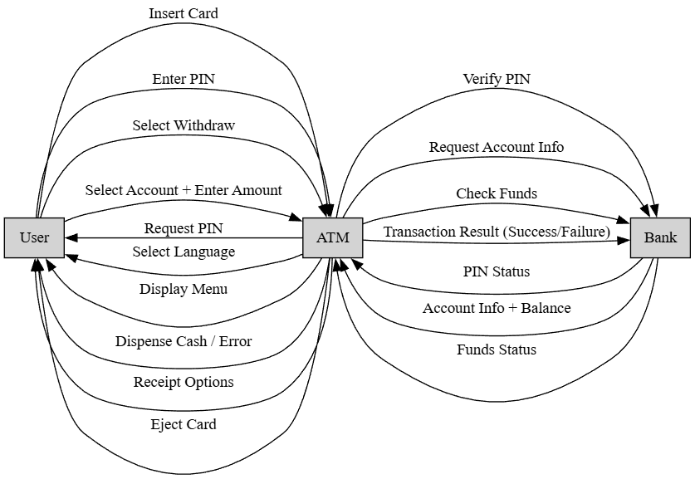

UML Class Diagram
Figure 5. Class Diagram
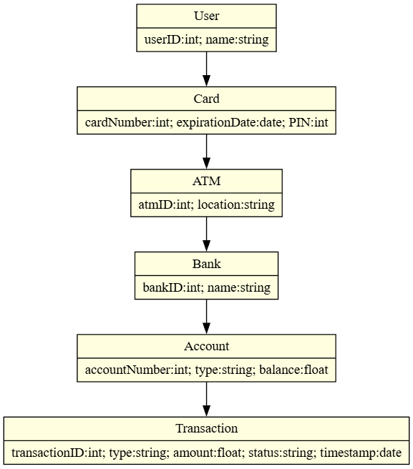

Technical Requirements
- Hardware Requirements
  - ATM machine with card reader, PIN pad or touch screen, cash dispenser, receipt printer, and display screen.
  - Secure vault to store cash until dispensed, with tamper-resistant locks.
  - Integrated camera system to record activity, especially during failed PIN attempts or suspicious transactions.
  - Silent alarm/safe trigger mechanism to alert authorities or bank security in case of tampering, robbery, or repeated failed access attempts.
  - Secure network interface hardware for communication with bank servers.
  - Reliable internet and electricity connection for continuous operation.
  - USB or maintenance port for direct/manual updates and diagnostics when remote updates are unavailable.
- Software Requirements
  - ATM operating system capable of managing user inputs, menu navigation, error handling, and secure communication with the bank.
  - Bank backend applications for PIN verification, account balance retrieval, funds availability checks, and transaction logging.
  - Middleware or API services to enable secure, bi-directional communication between ATM and bank systems, including transaction feedback.
  - Encryption libraries to protect sensitive data such as PINs and transaction details.
  - Remote update capability to push patches, security updates, and new features without requiring physical access.
  - Monitoring software to track cash levels in the vault and automatically notify the bank when replenishment is required.
  - Security software to trigger alerts when multiple failed transactions occur or when a card is flagged as locked.
- Tools and Development Requirements
  - UML modeling tools (e.g., Graphviz, Lucidchart) for system design and documentation.
  - Programming languages/frameworks suitable for embedded systems and secure financial applications (e.g., Java, C++, .NET).
  - Logging and monitoring tools to track transactions, detect errors, and support auditing.
  - Testing frameworks to validate workflows, retry loops, and error handling before deployment.
- Infrastructure Requirements
  - Reliable, high-speed network connectivity between ATMs and bank servers.
  - Centralized database systems for storing account information and transaction records.
  - Security infrastructure including firewalls, intrusion detection systems, and redundancy to ensure continuous availability.
  - Support for multilingual interfaces (English/Spanish) to meet accessibility requirements.
  - Transaction feedback mechanisms to ensure every user interaction (withdrawal, balance inquiry, failed attempt) is logged and synchronized with the bank system.
  - Scheduling system to coordinate cash replenishment, ensuring ATMs are restocked before funds run low.
  - Remote monitoring infrastructure to support surveillance feeds, silent alarms, and automated alerts to bank security teams.

